AppStoreBot Tips：

1. We need to install Memu to run Appstorebot. After we login Appstorebot, there will be a popped up page asking or setting Menu Installation path, like picture below:

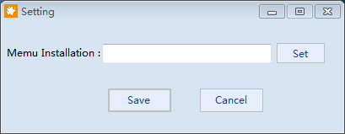

Find path like below picture, then restart software:

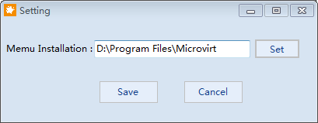

MEmu download link：https://www.memuplay.com/blog/release-archive.html

**Pls note, it needs to 7.5.3 version, otherwise there will be problem in running.**

1. To run task with Memu, pls note that one task needs one Memu. So when we run multiple tasks, then need to create multiple Memu, for example 5 tasks, then 5 Memu.

**The system of Memu must be Android 7.1**

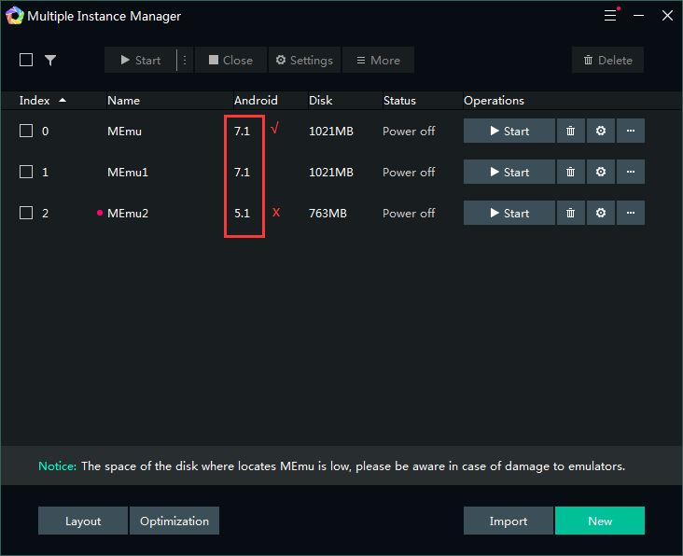

1. Set the Memu resolution to be phone and side 720*1280, like picture below:

